Power of the Pen 4 week workshop.

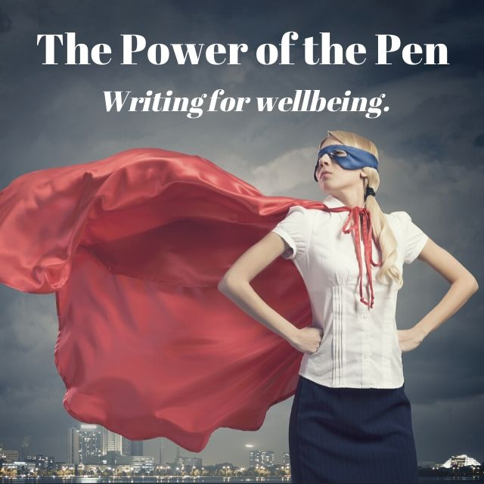

( Image purchased from Canva)

COST: $195 ( 4 week course, running for 2.5-3 hours hours per week)

Each week we will run through a series of fun and thought-provoking exercises to help you explore the mighty power of the pen. You will be exploring and focusing on writing for yourself and enjoying writing as a process – not finished product.

You will learn:

- How to incorporate different techniques into your daily writing practice and use them to alleviate stress, uncertainty or anxiety
- to experiment with different forms of expressive writing, helping you to freely express your voice and emotions and page. Remember: The page is the stage for your voice! It doesn't judge.
- to experiment with different writing techniques to help you make sense of the present, future or past.
- to discover, or rediscover, the simple joy of writing for yourself.
- Practise journaling, freewriting, poetry and fiction exercises each week.
You will have plenty of time to write, share and play with words, with coffee/tea and cake provided ( if face to face workshop at the Hunter Artisan Gallery and Café, Maitland). If you are wanting to explore the therapeutic benefits of writing in a safe, fun and supportive group - then this is the workshop for you!

Who is the course suitable for?

- Anyone with an interest in writing, including beginners, ex-journallers or ‘closet’ writers who want to start writing again.
- Those who want to establish a more regular writing practise.
- For experienced or emerging writers who have lost the joy of writing and would like to reconnect with the writing process (and their own voice) again.
- Suitable for anyone who would like to reconnect with the writer within, learning new techniques to express themselves on the page.
- Suitable for anyone with an interest in learning about the connection between creativity/the arts and mental health.

Disclaimer: This workshop is not suitable for those currently experiencing moderate to severe anxiety or depressive symptoms or mental illness, as some exercises may be triggering. Please seek advice from a counsellor if you are unsure. The workshop is designed to encourage students to use expressive writing for more general therapeutic benefit and to improve wellbeing. Please phone Michelle if you have any concerns or if you’d like to chat confidentially about whether the course is suitable for you.

Each week, we will practise, and reflect on:
Freewriting:
You will practise freewriting to music and different prompts. Learn simple ways to get the creative juices flowing and your words down on the page. We will also explore tips to disengage the critical mind and focus on mindfulness freewriting, which aims to quieten the busy chatter of the mind.

Journaling/Writing the Self:
You will experiment with different types of journaling, looking at various techniques to enhance clarity, self-expression and personal growth. We will practise writing a letter to the wise self, and will play ‘musical writing chairs’, where you move around between different tables and practise various journaling exercises, including dialoguing with your self. ( N.B: slightly different format for online/Zoom sessions)

Poetry:
Think you can’t write poetry? Think again! We will read and discuss some poems and how they relate to your own personal experience and then craft a new poem in response. This is perfect for those who want to experiment with different genres of writing and learn how they can be expressive and revealing.

Metaphor/Fiction - We will look at fun and interesting ways of writing about, and making meaning of, your own personal experiences - transforming your own personal narrative in the process. We will use images and photographs and metaphor to safely write about your own experience/s. Reimagine part of your life as a fairytale or your favourite book character – you’ll be surprised at what shows up during the process.
Please bring:
Pen/pencil and journal (paper/notepad). Please do not bring a laptop - they are actively discouraged as handwriting assists with creativity.

Cost: $195. For more information, phone Michelle on 0424 771 075. Please pay via website. I can take credit card payments over the phone, or you can pay on my website www.bookanookstudio.com.au. or you can also pay via direct debit. Session are offered face-to face, but currently are being offered on Zoom due to COVID-19 restrictions.

About the facilitator:

Michelle ( M.J.) Reidy is an award winning writer and artist from the Central Coast, NSW. Her stories have appeared in: Elle, ABC, Award Winning Australian Writing, INK3, Australian Poetry Slam, Monologue Adventures Voices of Women project and LitLive (WA) amongst others. In 2018, she was the winner of Elle’s national short story prize, a finalist in the Newcastle Short Story Prize ( Commended) and a panellist at the Australian Short Story Festival in Perth. She was recently longlisted for the Masters Review Summer Short Story Award (U.S). Her former background is in non-clinical mental health, where she worked for many years as a mentor, counsellor and manager. She facilitates writing workshops in the Hunter and Central Coast region, passionate about encouraging people to use storytelling as a tool for growth, recovery and healing.

